KMEI WATER METER TECHNICAL DATA SHEET

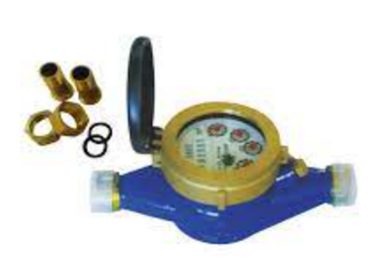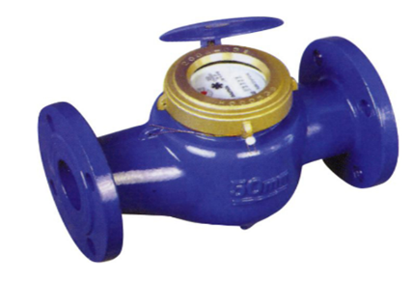
NR-KMEI
Application
Measuring the volume of cold portable water through the pipeline.
Features
The KM series water meter is a multijet wet type water meter designed in accordance with class B of ISO4064 with body made from brass and iron designed to work with maximum operating pressure <10 bar.
Performance Data
Nominal Size (DN) | Maximum Operating Temperature | Q3/Q1 | Max Flow Rate (Q4) | Permanent Flow Rate (Q3) | Transitional Flow Rate (Q2) | Minimum Flow Rate (Q1) | Minimum Reading | Maximum Reading
mm | <45ºc |  | M³ |  |  |  | M³
15 | <45ºc | 80 | 3.125 | 2.5 | 0.05 | 0.03125 | 0.0001 | 99999
20 | <45ºc | 80 | 5 | 4 | 0.064 | 0.04 | 0.0001
25 | <45ºc | 80 | 7.875 | 6.3 | 0.126 | 0.07875 | 0.0001
40 | <45ºc | 80 | 20 | 16 | 0.32 | 0.2 | 0.0001
50 | <45ºc | 80 | 31.25 | 25 | 0.5 | 0.3125 | 0.0001

Dimensions and Weight
Type | Size | Length |  | Width | Height | Connecting Thread (D) | Weight (kg)
 | mm
NRKM-15E | 15 | 165 |  | 99 | 104 | ¾” | 1.5
NRKM-20E | 20 | 195 | 190 | 99 | 106 | 1” | 1.8 | 1.7
NRKM-25E | 25 | 225 | 260 | 104 | 120 | 1 1/4” | 2.4 | 2.6
NRKM-32E | 32 | 230 | 260 | 104 | 120 | 1 ½” | 2.8 | 3.0
NRKM-40E | 40 | 245 | 300 | 125 | 155 | 2” | 4.8 | 5.1
NRKM-50E | 50 | 280 | 300 | 125 | 155 | 2 ½” | 7.2 | 8.5
 |  | 280 |  | 158 | 175 | Connecting Flanges D=Ø165 D1=Ø125 | 11

